Programa llamador (caller) al presionar ctrl.+K

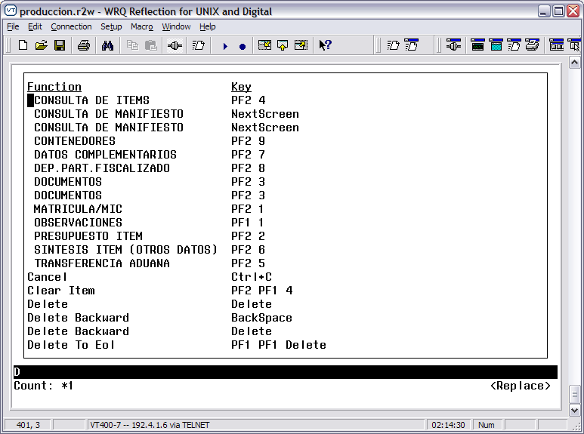

Nótese que se repite NextScreen y PF2 3.
Un solo block define en el form el uso de ambas teclas (Only a block defines both keystrokes).

When press PF2 4 (Consulta de ítems) a new form is called, with its keystrokes. When press Ctrl+K…….. seeee…

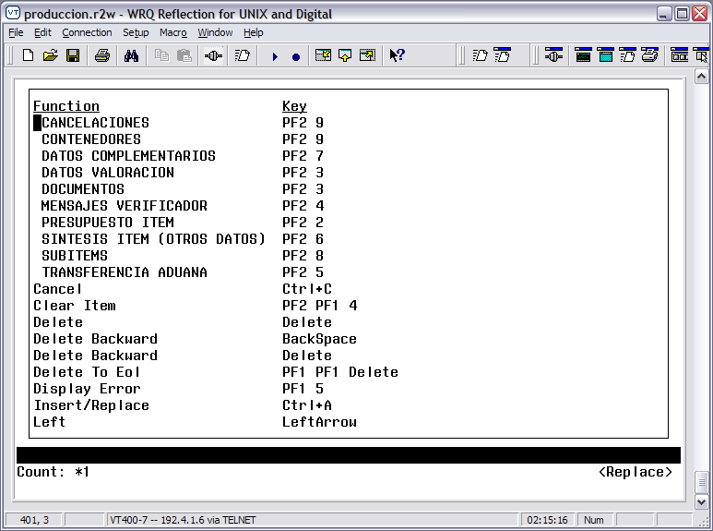
For this form, only a block defines the F9-key (Cancelaciones), but …. Then F9-key of the form caller (Contenedores) is visible here!!!. Great confussion!!!

